-- Task 1. Display the names of the unique launch sites in the space mission --

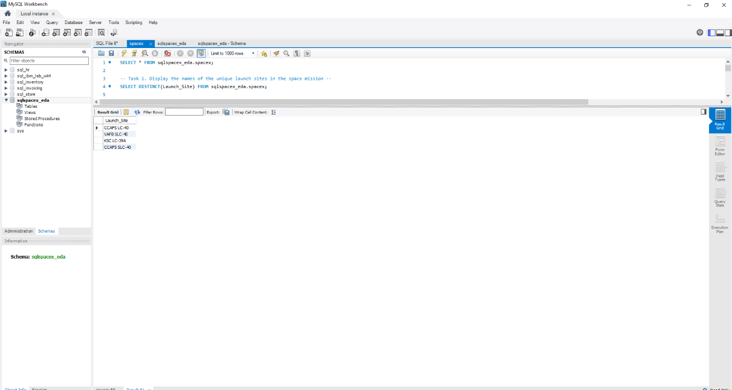

-- Task 2. Display 5 records where launch sites begin with the string 'KSC'--

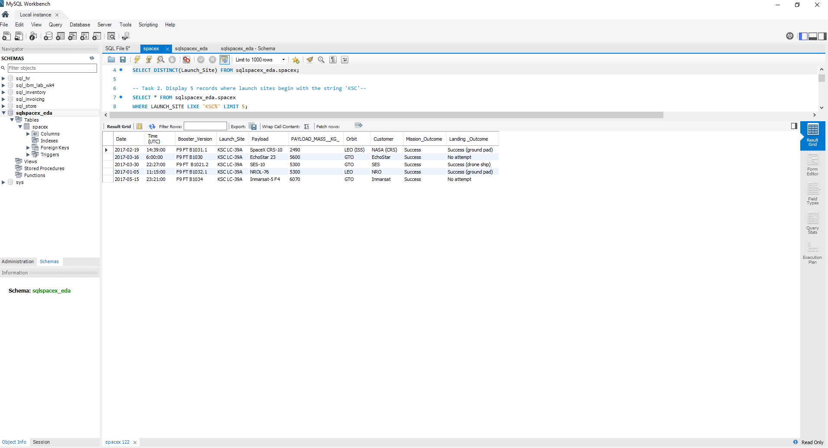

-- Task 3. Display the total payload mass carried by boosters launched by NASA (CRS)--

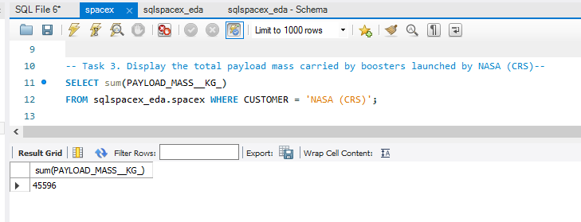

-- Task 4.Display average payload mass carried by booster version F9 v1.1--

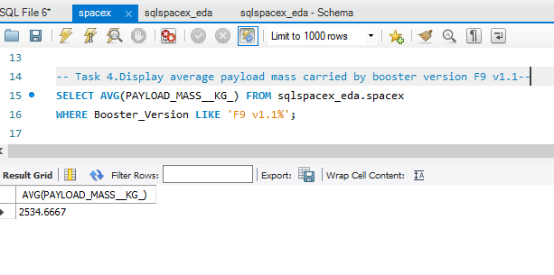

-- Task 5.List the date where the first succesful landing outcome in drone ship was achieved.--

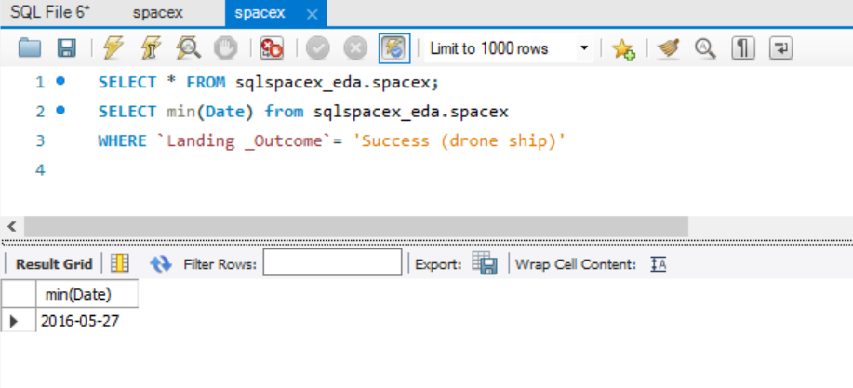

-- Task 6.List the names of the boosters which have success in drone ship and have payload mass greater than 4000 but less than 6000--

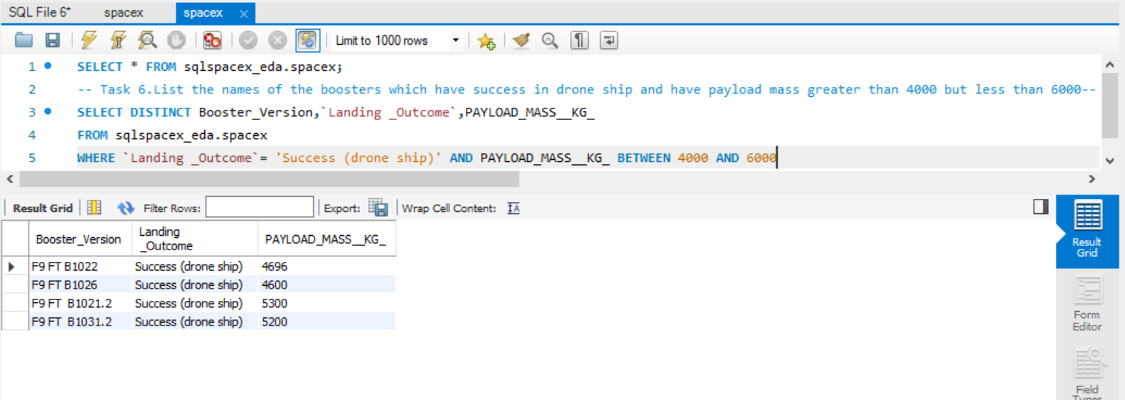

-- Task 7. List the total number of successful and failure mission outcomes—

Successful:

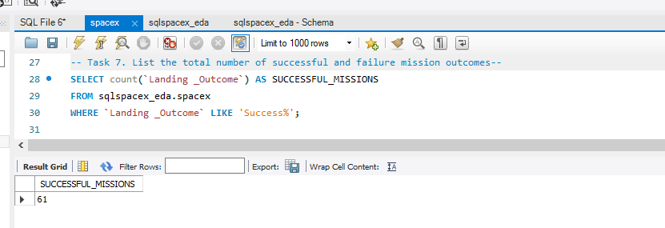

Failure:

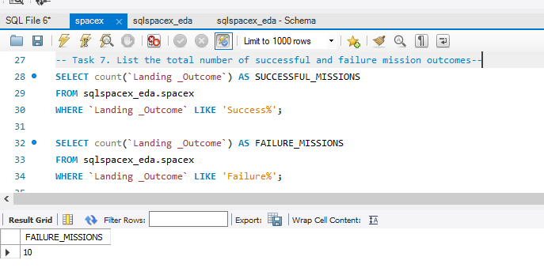

-- Task 8.List the names of the booster_versions which have carried the maximum payload mass. Use a subquery--

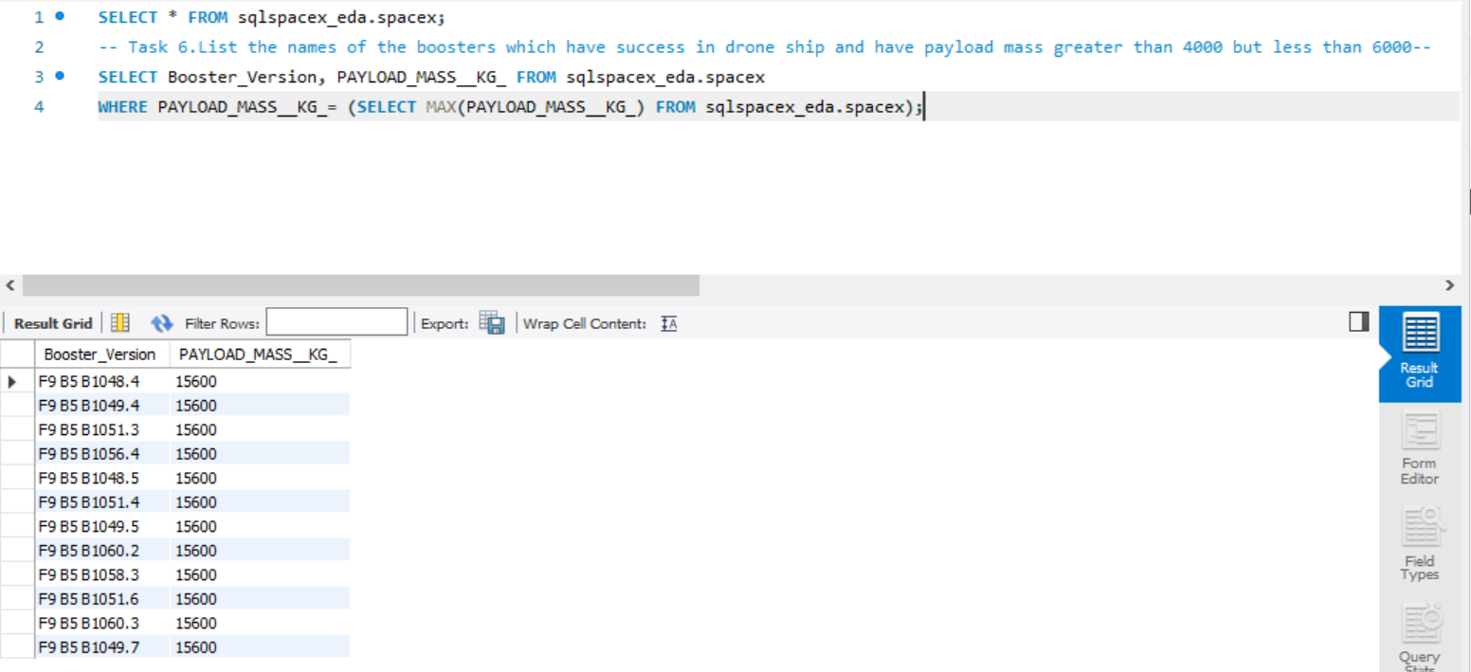

-- Task 9.List the records which will display the month names, successful landing_outcomes in ground pad ,booster versions, launch_site for the months in year 2017 --

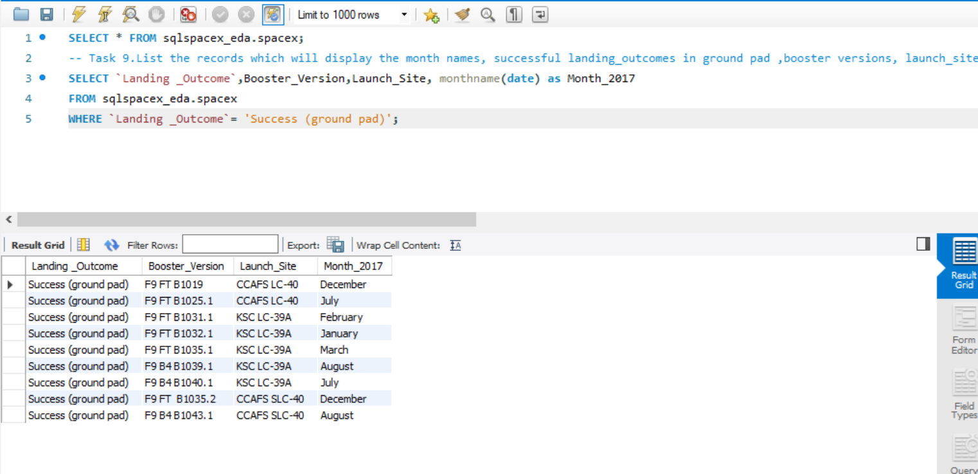

-- Task 10. Rank the count of successful landing_outcomes between the date 2010-06-04 and 2017-03-20 in descending order.--

